TOURIST AGENCY DASHBOARD

MODEL

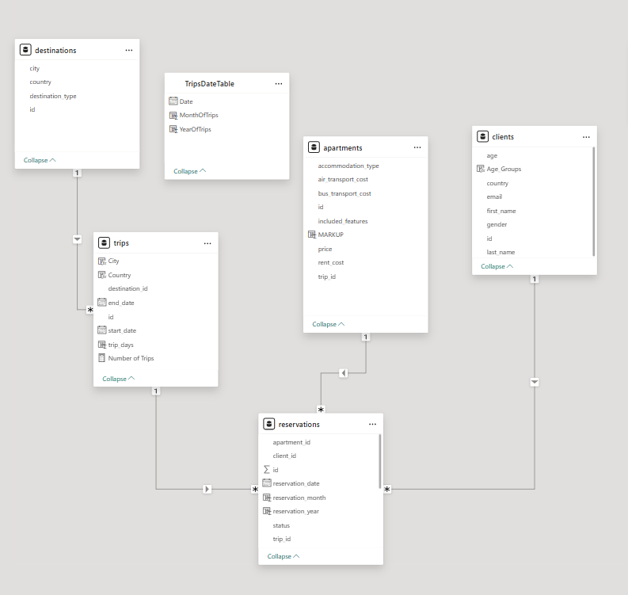

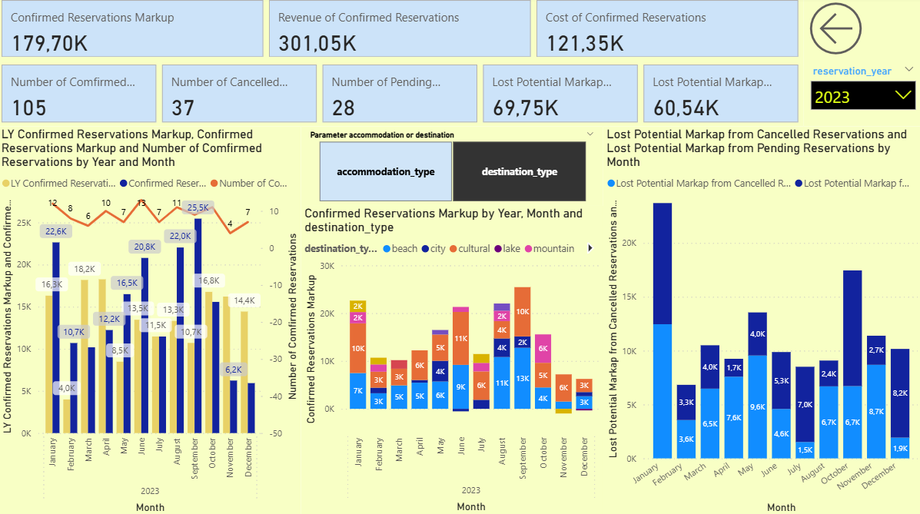
VS
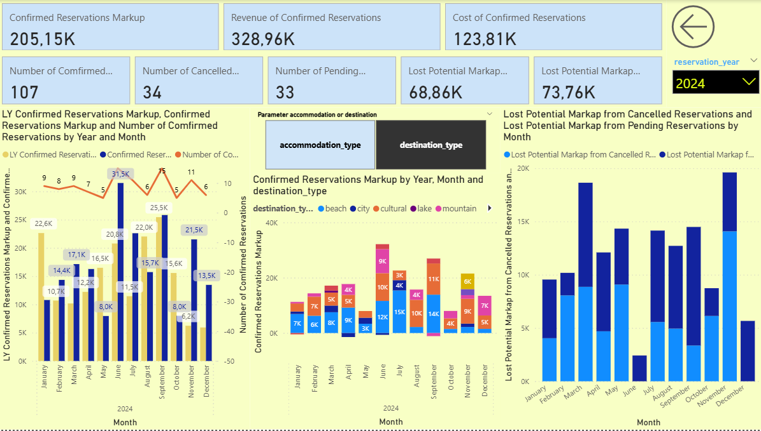

🔹 Overall Financial Performance
Metric | 2023 | 2024 | Difference
Confirmed Reservations Markup | 179.70K | 205.15K | +25.45K ↑
Revenue from Confirmed Res. | 301.05K | 328.96K | +27.91K ↑
Cost of Confirmed Res. | 121.35K | 123.81K | +2.46K ↑
Net Margin Increase |  |  | Improved ✅
Conclusion: 2024 shows improved financial performance with increased revenue, markup, and only a slight rise in costs.

🔹 Reservation Statistics
Metric | 2023 | 2024 | Change
Confirmed Reservations | 105 | 107 | +2
Cancelled Reservations | 37 | 34 | -3
Pending Reservations | 28 | 33 | +5
Conclusion: Slight increase in confirmed and pending reservations in 2024, with fewer cancellations – indicating improved booking confidence or customer satisfaction.

🔹 Lost Potential Markup
Category | 2023 | 2024 | Change
From Cancelled Reservations | 69.75K | 68.86K | -0.89K ↓
From Pending Reservations | 60.54K | 73.76K | +13.22K ↑
Conclusion: While cancellations caused slightly less lost markup in 2024, pending reservations had a significantly higher potential loss – possibly due to higher-value bookings not being finalized yet.

🔹 Monthly Markup Trend (Confirmed Reservations)
- Peak month in 2023: August (25.5K)
- Peak month in 2024: June (31.5K)
Trend Insight:
- The highest earning month shifted from August (2023) to June (2024), possibly due to changes in travel demand, promotions, or seasonality.
- 2024 had stronger monthly performance from April to August, surpassing 2023 values.

🔹 Destination Type Insights
- Beach and City destinations remain top contributors in both years.
- Mountain and Lake types saw moderate improvements in 2024.
- More even distribution across destination types in 2024 suggests diversification in customer preferences or offerings.

🔹 Lost Potential by Month
- 2023: February had the highest lost potential (~23K), mostly from cancellations.
- 2024: December was the most impacted (~19K), with high pending values.
- Overall, 2023 losses were more due to cancellations, while 2024 losses leaned toward pending reservations, indicating customers might be taking longer to confirm.

✅ Key Takeaways
- 2024 outperforms 2023 in all key financial metrics.
- Fewer cancellations and more confirmed reservations indicate operational improvements.
- Higher pending reservation value in 2024 is both an opportunity and a risk.
- Destination variety and demand timing have shifted, with more revenue concentration in early summer (especially June).

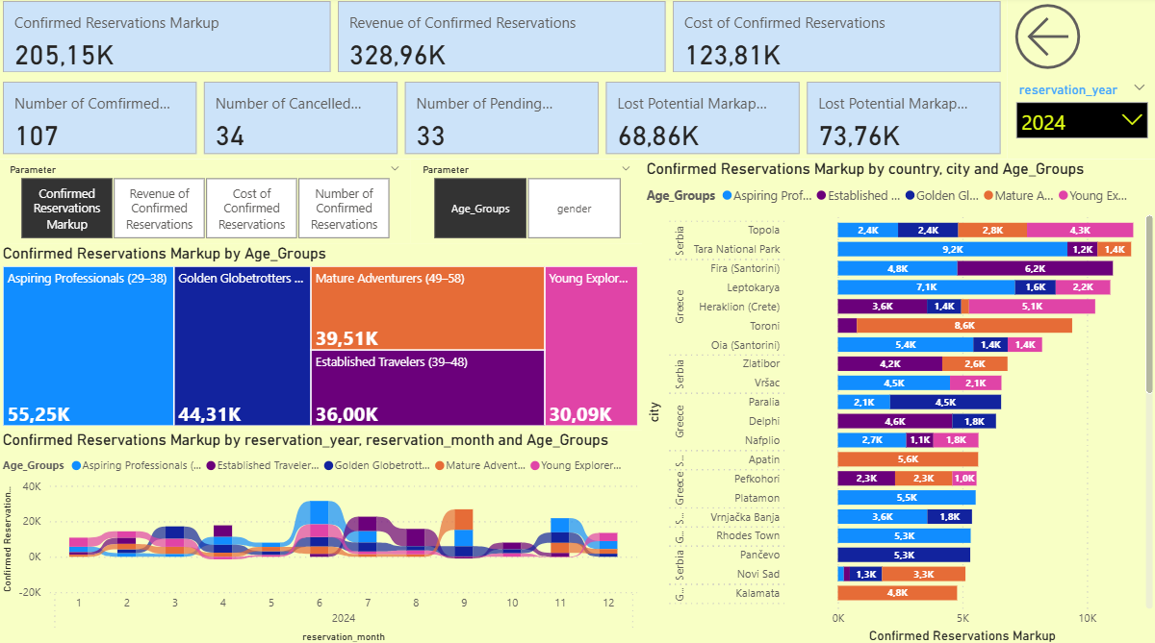
VS

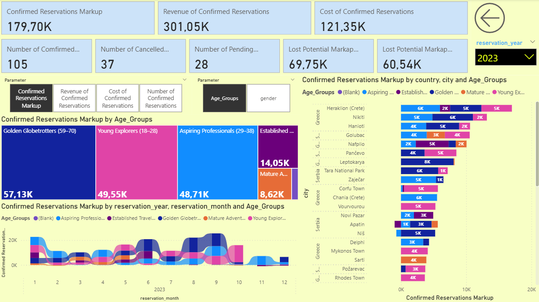

Insights:
- There's a major shift in market segments.
  - 2023 was dominated by older age groups (Golden Globetrotters and Young Explorers).
  - 2024 saw a surge in middle-aged travelers (Mature Adventurers and Established Travelers).
- Aspiring Professionals (29–38) remained consistently strong in both years.
- The Young Explorer segment saw a significant decline in 2024, possibly due to price sensitivity or changing travel habits.
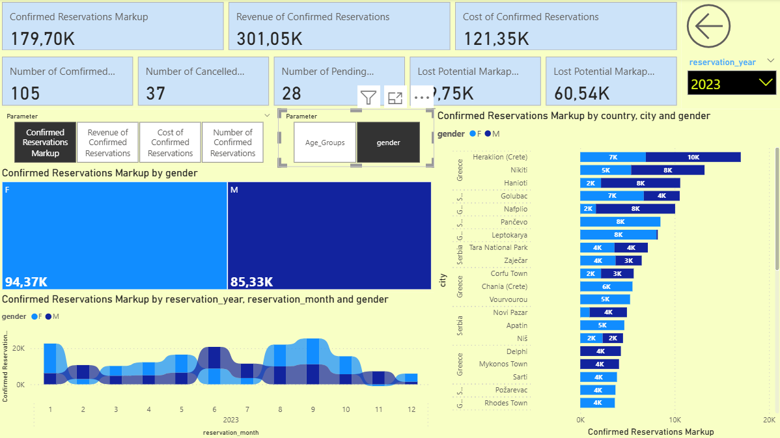
VS
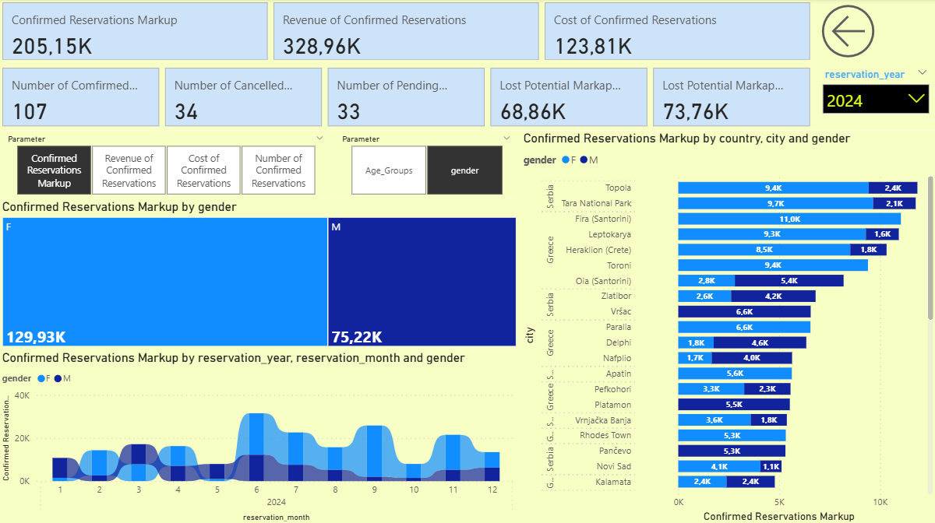

👥 1. Confirmed Reservations Markup by Gender
Gender | 2023 Markup (K) | 2024 Markup (K) | Absolute Change | % Change
Female (F) | 94.37K | 129.93K | +35.56K | +37.7% ↑
Male (M) | 85.33K | 75.22K | -10.11K | -11.8% ↓
Insights:
- In 2024, women dominated the market, contributing 63.4% of total markup, up from 52.5% in 2023.
- Male travelers decreased both in absolute value and relative share.

🗓️ 2. Monthly Trends by Gender
2023:
- Male and female trends were fairly balanced throughout the year.
- Peak activity was in June–September, with a noticeable spike in August.
2024:
- Female travelers had stronger peaks, especially:
  - June, July, and September
- Male contribution remained relatively flat and lower than females throughout the year.
Insight: In 2024, women are driving the summer season, especially around popular beach and nature destinations.

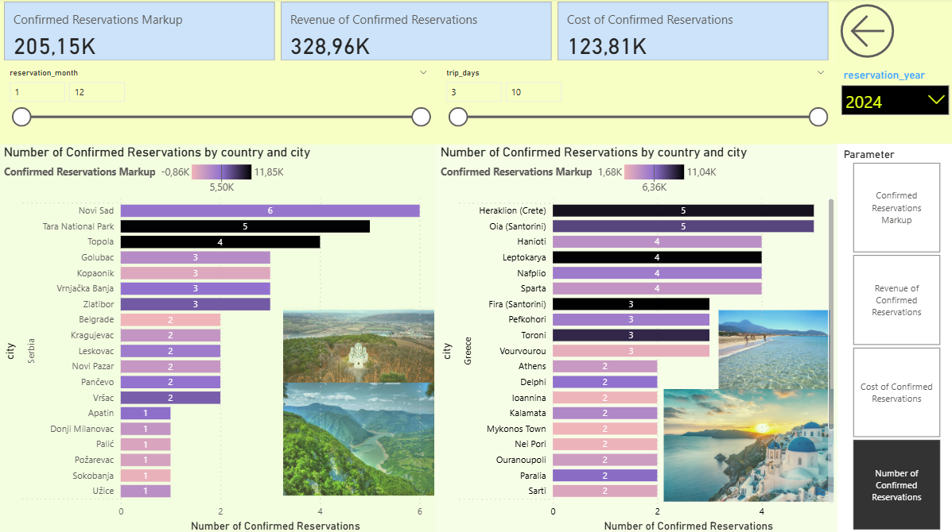
VS
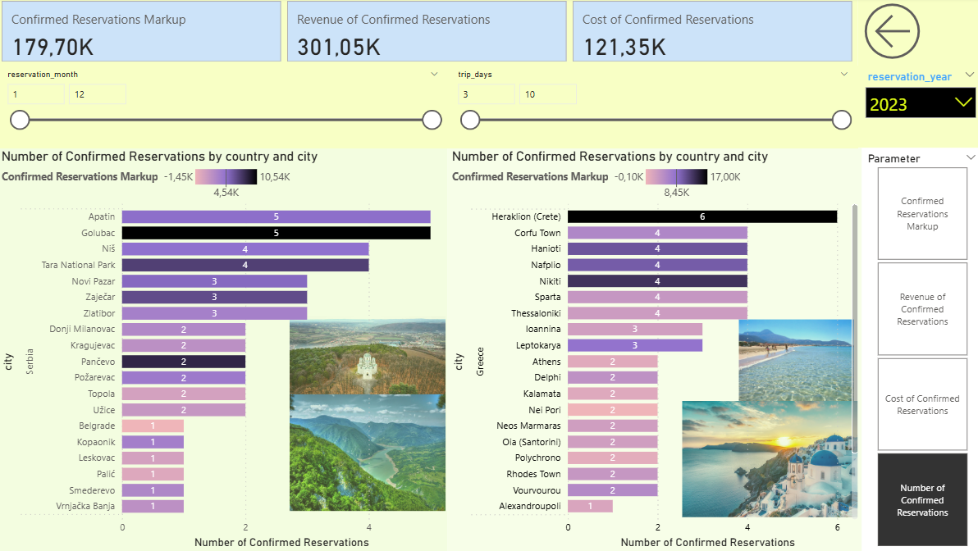

Observation:
- Topola and Tara National Park saw the largest profitability boost in 2024.
- Apatin saw a sharp drop in markup despite having 5 reservations in 2023.
- Novi Sad gained in both reservation count and profitability.
• Oia (Santorini) and Toroni saw major jumps in profitability.
• Heraklion remains consistently top-tier, though slightly less than in 2023.
• More concentration of high-markup destinations in 2024 vs. a broader mix in 2023.

📌 Key Takeaways:
- 2024 brought more high-markup performance in fewer concentrated cities — both in Serbia and Greece.
- Oia, Toroni, and Topola are the new standout destinations in terms of profitability.
- Some 2023 destinations saw a significant fall in markup in 2024 despite similar booking counts (e.g., Apatin).

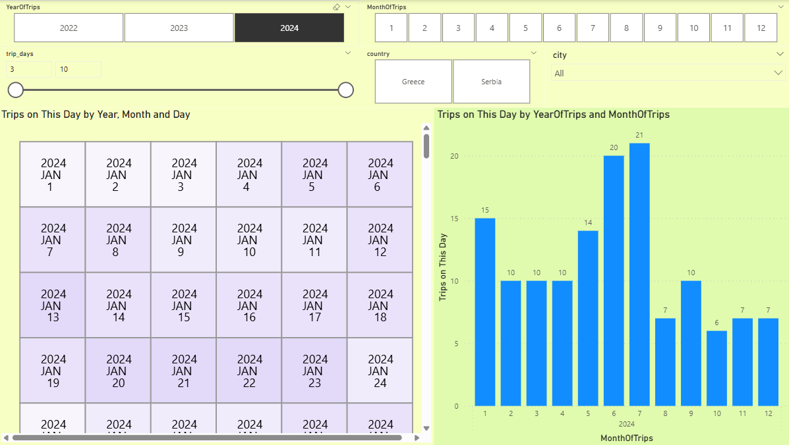
VS
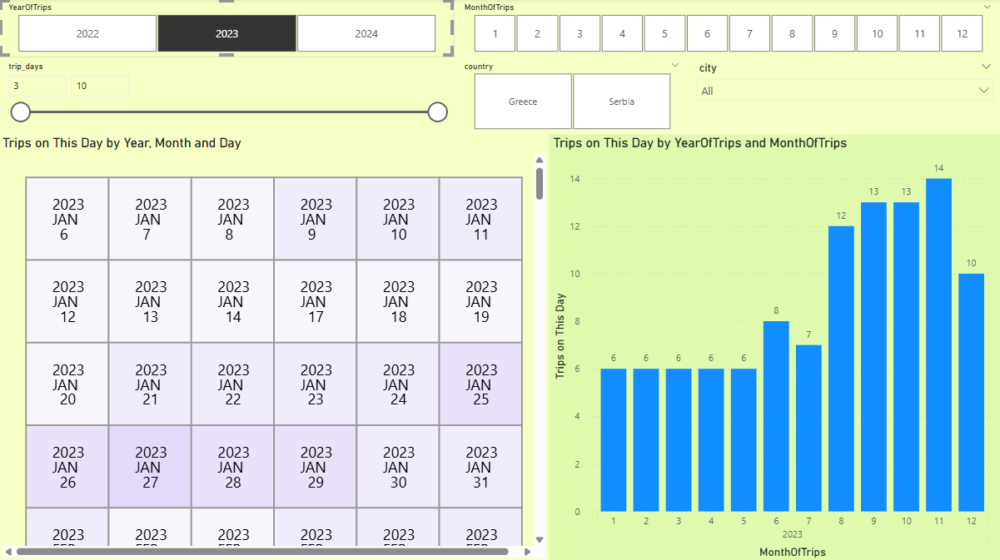
📈 Key Insights:
- Highest trip month in 2023: October (14 trips)
- Highest trip month in 2024: July (21 trips)
- Consistently low months (2023): Jan to Apr (6 trips each)
- Strong growth in summer 2024: June (20) and July (21) show a major increase from 2023 values (June 7, July 12)
- Decreased activity in Aug–Dec 2024 compared to 2023

📌 FINAL TAKEAWAYS:
- 2024 was a stronger year overall in revenue, efficiency, and strategic destination targeting.
- Traveler profile evolved, with more middle-aged and female travelers dominating key seasons.
- Operational efficiency improved, with lower cancellations and better markup per booking.
- Focus for growth:
  - Convert high-value pending reservations
  - Continue capitalizing on strong-performing cities
  - Target female and middle-aged demographics with summer-focused offerings

